WEEK 4 OS LAB

Q) Write a C program to simulate a multi-level queue scheduling algorithm considering the following scenario. All the processes in the system are divided into two categories – system processes and user processes. System processes are to be given higher priority than user

processes. Use FCFS scheduling for the processes in each queue.

SOURCE CODE:

#include <stdio.h>

#define MAX_QUEUE_SIZE 100

// Structure to represent a process

typedef struct {

int processID;

int arrivalTime;

int burstTime;

int priority; // 0 for system process, 1 for user process

} Process;

// Function to execute a process

void executeProcess(Process process) {

printf("Executing Process %d\n", process.processID);

// Simulating the execution time of the process

for (int i = 1; i <= process.burstTime; i++) {

printf("Process %d: %d/%d\n", process.processID, i, process.burstTime);

}

printf("Process %d executed\n", process.processID);

}

// Function to perform FCFS scheduling for a queue of processes

void scheduleFCFS(Process queue[], int size) {

for (int i = 0; i < size; i++) {

executeProcess(queue[i]);

}

}

int main() {

int numProcesses;

Process processes[MAX_QUEUE_SIZE];

// Reading the number of processes

printf("Enter the number of processes: ");

scanf("%d", &numProcesses);

// Reading process details

for (int i = 0; i < numProcesses; i++) {

printf("Process %d:\n", i + 1);

printf("Arrival Time: ");

scanf("%d", &processes[i].arrivalTime);

printf("Burst Time: ");

scanf("%d", &processes[i].burstTime);

printf("System(0)/User(1): ");

scanf("%d", &processes[i].priority);

processes[i].processID = i + 1;

}

// Separate system and user processes into different queues

Process systemQueue[MAX_QUEUE_SIZE];

int systemQueueSize = 0;

Process userQueue[MAX_QUEUE_SIZE];

int userQueueSize = 0;

for (int i = 0; i < numProcesses; i++) {

if (processes[i].priority == 0) {

systemQueue[systemQueueSize++] = processes[i];

} else {

userQueue[userQueueSize++] = processes[i];

}

}

// Execute system queue processes first

printf("System Queue:\n");

scheduleFCFS(systemQueue, systemQueueSize);

// Execute user queue processes

printf("User Queue:\n");

scheduleFCFS(userQueue, userQueueSize);

return 0;

}

OUTPUT:-

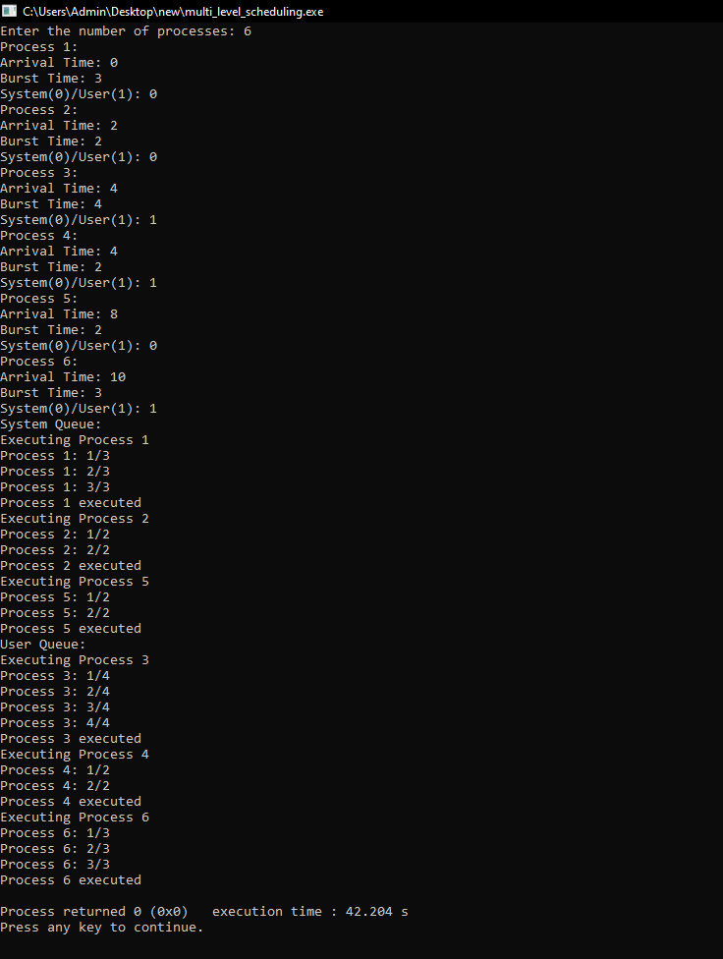

Q) Simulate Earliest Deadline First for the following and show the order of execution of processes in CPU timeline:

SOURCEC CODE:-

#include <stdio.h>

#include <stdlib.h>

#define MAX 10

int n;

int period[MAX], execution[MAX], deadline[MAX];

int ready[MAX], task[MAX];

int time = 0;

void swap(int *a, int *b) {

    int temp = *a;

    *a = *b;

    *b = temp;

}

int gcd(int a, int b)

{

    if (b == 0)

        return a;

    return gcd(b, a % b);

}

void sort() {

    for (int i = 0; i < n - 1; i++) {

        for (int j = i + 1; j < n; j++) {

            if (deadline[i] > deadline[j]) {

                swap(&period[i], &period[j]);

                swap(&execution[i], &execution[j]);

                swap(&deadline[i], &deadline[j]);

            }

        }

    }

}

int lcm(int arr[], int n)

{

    int ans = arr[0];

    for (int i = 1; i < n; i++)

        ans = (((arr[i] * ans)) / (gcd(arr[i], ans)));

    return ans;

}

void schedule() {

    int i, j;

    for (i = 0; i < n; i++) {

        if (time % period[i] == 0) {

            ready[i] = 1;

        }

    }

    for (i = 0; i < n; i++) {

        if (ready[i] == 1) {

            int min_deadline = 1000000000;

            int min_index = -1;

            for (j = 0; j < n; j++) {

                if (ready[j] == 1 && deadline[j] < min_deadline) {

                    min_deadline = deadline[j];

                    min_index = j;

                }

            }

            task[min_index] += execution[min_index];

            deadline[min_index] += period[min_index];

            ready[min_index] = 0;

        }

    }

}

int main() {

    int total_time;

    printf("Enter the number of processes: ");

    scanf("%d", &n);

    printf("Enter the period, execution time and deadline of each process:\n");

    for (int i = 0; i < n; i++) {

        scanf("%d %d %d", &period[i], &execution[i], &deadline[i]);

        ready[i] = task[i] = 0;

    }

    sort();

    printf("\nOrder of execution of processes in CPU timeline:\n");

    total_time = lcm(period, n);

    while (time < total_time) { // assuming total time is 100

        schedule();

        printf("%d ", task[0]);

        time++;

    }

    return 0;

}

OUTPUT:-

